Domain Group: Perinatal/Infant
Expert Guest(s): Christy Schunn & Dr. Cari Schmidt
Lead Staff: Carrie Akin Recorder: Tamara Jones

Focus Area: Provide brief responses to the following questions related to the focus area/issue.
Discussion Questions | Comments
- What is the problem/focus issue? | Although the SUID/SIDS rates have been trending down over the past five years, the rates are not declining at a significant enough rate or fluctuating year to year (increasing vs. decreasing). This is occurring despite all of the investments, consistent messaging across the periods, and integration efforts. Additionally, KS PRAMS data is available for the first time and reveals there is room for improvement. Infants are not always positioned safely or placed on a safe surface. (2017 report available online at: http://www.kdheks.gov/prams/). Discussion will focus on messaging for all to be a part of the solution (behaviors around safe sleep practices). The recommendations and practices are the same whether you’re in a hospital, outpatient setting, child care setting, maternity center, or at home.
- Who is the target audience for the message(s)? | Audience is all (parents, caregivers, families, physicians, communities, etc.) with a l focus on providers.
- What type of document/product related to outreach/messaging are you preparing (what is the purpose) and why? (action alert, infographic, bulletin, etc.) | Action Alert/Call to Action  (Use data, strategies, tips, and reminders to send the messages to impact behavior; intent is to mobilize and activate/create and drive action across sectors – we are all a part of the solution and can do something now.)
- What MCH performance measure does this aim to address/support? | NPM 5 (NEW in 2019): Source - KS PRAMS  - A) Percent of infants placed to sleep on their backs  - B) Percent of infants placed to sleep on a separate approved sleep surface  - C) Percent of infants placed to sleep without soft objects or loose bedding  NOM 9.5 # of sleep related deaths
- Outline the case for need:  - Data/negative trends  - Behaviors to target for change that are contributing to the issue  - System and/or policy issues and barriers contributing to the problem  - Other contributing factors | Data: During the five-year period (2013-2017), overall SUID rates in Kansas decreased by 1.5 per year (95% CI: -16.5, 16.3), from 131.4 deaths per 100,000 live births in 2013 to 107.0 deaths per 100,000 live births in 2017. This decrease was not statistically significant. During 2013-2017, 216 Kansas infants died due to sleep-related deaths. Sleep-related deaths are the third most common cause of infant deaths in Kansas (18.4%), behind deaths due to prematurity or low birthweight (19.0 %) and congenital anomalies (23.5%). Non-Hispanic black infants (33 cases, 259.4 deaths per 100,000 live births, 95% CI: 178.6, 364.3) died at a significantly greater rate than non-Hispanic white (127 cases, 93.5 deaths per 100,000 live births, 95% CI: 77.3 – 109.8), and Hispanic infants (35 cases, 113.6 deaths per 100,000 live births, 95%CI: 79.1 – 158.0) where the cause of death was SUID. SEE ATTACHED. NOTE: The 2017 KS PRAMS data is available on the attached pages.  Behaviors to Target:  System and/or Policy Issues:  Barriers to Address:  Other Factors to Consider:
- What are the “asks” from the audience? What changes/actions can make a difference? Specifically, how should we move forward with this “issue” area that needs to be advanced?
(Carry to action alert worksheet.)
NOTE: Break strategies/actions for change down by target population and provider or setting type

- What key message(s) or resources (phone numbers, websites, etc.) need to be communicated or promoted?
(Carry to action alert worksheet.)
NOTE: Break message down by target population and provider or setting type, if appropriate.

- Sources/References

MCH State Action Plan Objectives & Strategies:
- Implement a multi-sector (community, hospitals, maternal and infant clinics) safe sleep promotion model by 2020.
  - Enhance safe sleep instructor skill sets to include training home visitors and health care providers and facilitating community baby showers expanding to address safe sleep, smoking cessation, and breastfeeding.
  - Provide essential supplies including sleep sacks and pack and plays to families and caregivers identified as at risk and in need.
  - Expand promotion of the American Academy of Pediatrics’ (AAP) Safe Sleep guidelines by activating the Safe Sleep Instructors to roll out the Hospital Safe Sleep Bundle Intervention and the Safe Sleep Toolkit for outpatient clinics.
  - Increase the number of Safe Sleep instructors by approximately 5 per year through targeted recruitment in areas with identified need for instructors, high rates of sleep-related injury or mortality, and low levels of related resources.

What, if any recommendations, does the group have for the MCH State Action Plan related to this issue? Consider and discuss the following:
Is the issue/need adequately addressed in the plan?  Circle one (yes or no) and explain. | Yes | No
Does the group recommend any strategies to advance the work or improve the outcomes/measures?  Circle one (yes or no) and explain. | Yes | No

Significance & Data:
Sleep-related infant deaths, also called Sudden Unexpected Infant Deaths (SUID), are the leading cause of infant death after the first month of life and the third leading cause of infant death overall. Sleep-related SUIDs include Sudden Infant Death Syndrome (SIDS), unknown cause, and accidental suffocation and strangulation in bed. Sleep-related SUIDs are the leading cause of death in infants from one month up to one year (postneonatal deaths) and account for approximately 15% of all infant deaths. SUID rates vary greatly by race and ethnicity. In 2013, SUID rates were highest for infants born to non-Hispanic black mothers and American Indian/Alaska Native (173 and 170 SUIDs per 100,000 live births, respectively); these rates were more than twice the rate among infants born to non-Hispanic whites (85 SUIDs per 100,000 live births). SUIDs account for 33% of the overall infant mortality gap between American Indian/Alaska Native and non-Hispanic whites and 15% of the gap between non-Hispanic blacks and non-Hispanic whites. To reduce SUIDs, the American Academy of Pediatrics recommends safe sleep practices, such as placing babies to sleep on their backs on a separate firm sleep surface without soft objects or loose bedding, as well as other protective practices such as breastfeeding and smoking cessation. Due to heightened risk of SIDS when infants are placed to sleep in side (lateral) or stomach (prone) sleep positions, the American Academy of Pediatrics (AAP) has long recommended the back (supine) sleep position. In 2011, AAP expanded its recommendations to help reduce the risk of all sleep-related deaths through a safe sleep environment that includes use of the back-sleep position, on a separate firm sleep surface (room-sharing without bed sharing), and without loose bedding. http://pediatrics.aappublications.org/content/128/5/1030

HEALTHY PEOPLE 2020 OBJECTIVE Identical to Maternal, Infant, and Child Health (MICH) Objective 20: Increase the proportion of infants placed to sleep on their backs (Baseline: 69.0%, Target: 75.9%) DATA SOURCES and DATA ISSUES Pregnancy Risk Assessment Monitoring System (PRAMS) MCH POPULATION DOMAIN Perinatal/Infant Health

KS PRAMS Data as Source for NPM 5
NPM 5 - A)
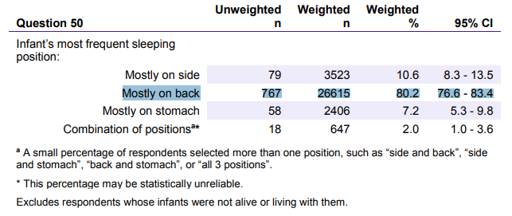
NPM 5 – B)
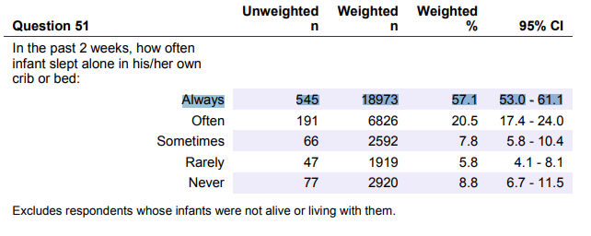

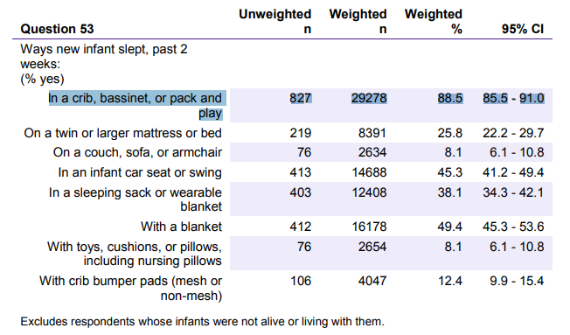

NPM 5 – C)

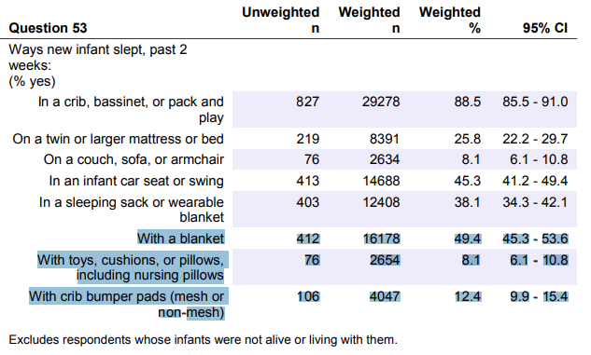

Additional Data and Resources:
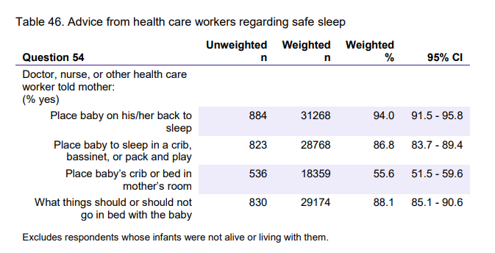

- Additional highlights and data provided by Christy Schunn and Dr. Schmidt based on the following resources:
  - HP 2020 U.S. comparison data
  - US PRAMS data for comparison
  - Child Death Review Board Report
  - Implementation of a Statewide Program to promote Safe Sleep… article
  - National and State Sudden Infant Death Trends article
  - MMWR article on Trends and Disparities in Safe Sleep Practices
  - Safe Sleep Interventions – Successful Behavioral Change Article
  - Example infographics

